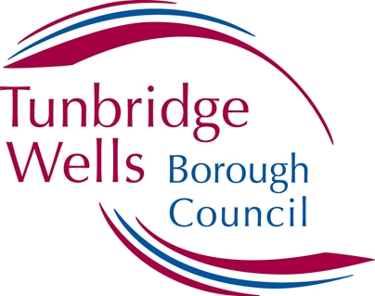

# Job Description

**Post title:**  Performance and Governance Manager

**Service:**  Governance and Democratic Services

**Grade:**  8

**Responsible To:**  Head of Governance and Democratic Services

**Responsible For:** Corporate Governance Officer x 3, Corporate Governance Assistant x 1

**Job Summary:** To manage the Council’s information, performance and corporate governance arrangements in line with internal policies and legislation such as the Data Protection Act, the Freedom of Information Act, the Equalities Act, and the Transparency Code.

**Main Activities:**

1. To provide line management to the Corporate Governance team, which includes carrying out monthly one-to-one meetings, annual development reviews, and providing advice and assistance with all types of casework.
2. Manage the Council’s information and corporate governance arrangements, ensuring compliance with all relevant legislation and internal policies around data protection, freedom of information, transparency, equalities, and corporate complaints.
3. Stay aware of and interpret changes to legislation, good practice, or new statutory guidance around information and corporate governance, and with the support of the Corporate Governance team and the Head of Service and DPO, implement those changes across the Council.
4. Monitor and report on the Council’s performance management, providing regular updates and recommendations to the Head of Governance and Democratic Services, Heads of Service, Management Board, and Council committees as required.
5. Manage the Council’s service planning process in conjunction with Heads of Service, including refreshing corporate plans and strategies, and refreshing performance indicators as appropriate.
6. Support the Head of Governance and Democratic Services in delivering corporate inspections, including any peer reviews, benchmarking or service review activity. Report recommendations and findings back to the Head of Governance and Democratic Services, Heads of Service, Management Board, or Council committees as required.
7. Support the Head of Governance and Democratic Services with developing and refreshing corporate-wide strategies and policies.
8. Support the Head of Governance and Democratic Services in research and policy matters, and perform data analysis of performance information, borough data and external statistics, to capture an overview of key indicators for the Borough and its residents.
9. Work with the Data Protection Officer, Heads of Service, and Service Managers to ensure the Council is compliant with its statutory duties around the Equalities Act, the Data Protection Act, the Freedom of Information Act, and the Transparency Code.
10. Manage the Council’s complaints process and provide support and advice to the Corporate Governance Officers when dealing with Stage 2 and Local Government Ombudsman (LGO) complaints.
11. When necessary, deputise for the Head of Governance and Democratic Services when reporting on performance or corporate and information governance to internal management meetings, Cabinet and committee meetings, or other stakeholder events.
12. To lead on and manage process reviews and digital transformation work within the Corporate Governance team that looks to maximise use of the Council’s case management system (eCase), Microsoft apps for data collection, and Microsoft Power BI for performance reporting.
13. To embed continuous improvement, innovation and excellence as the service ethos of the Corporate Governance team.
14. To be aware of and exercise personal and corporate responsibilities under the Health and Safety at Work Act and other related matters.

**NB This job description is not intended to be an exhaustive list of all the tasks and responsibilities of the post. In line with Service needs, some tasks may need to change, and any changes will be made in consultation with the postholder.**